ATHENA PROJECT

Objective: Recognize a trend in a database based on correlations.

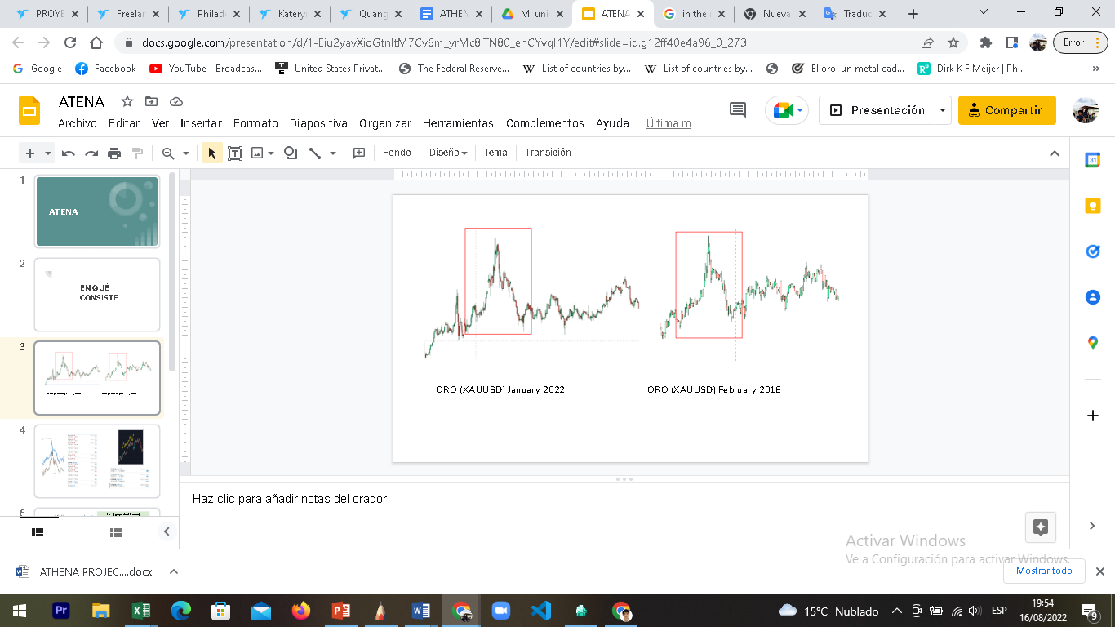

1. Have a database of any asset, use only the close prices.
2. Divide all prices into groups of 4 (each group 4 bars)
   1. Identify the growth or decrease rate in percentage % from the first bar to the 4th bar, of all groups of the asset, create another variable according to results.

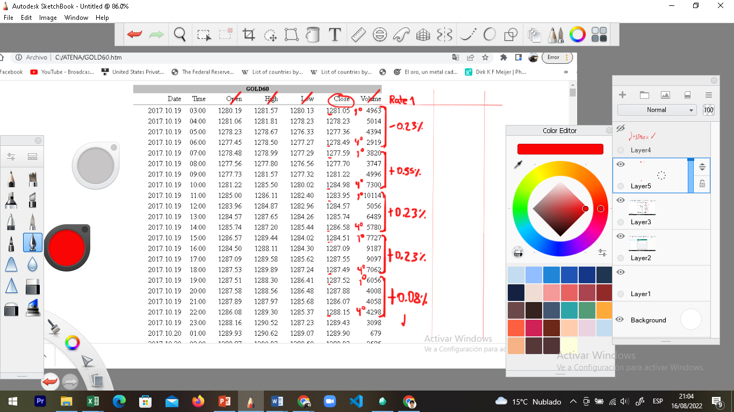

* 1. Do the same again with the results of a).

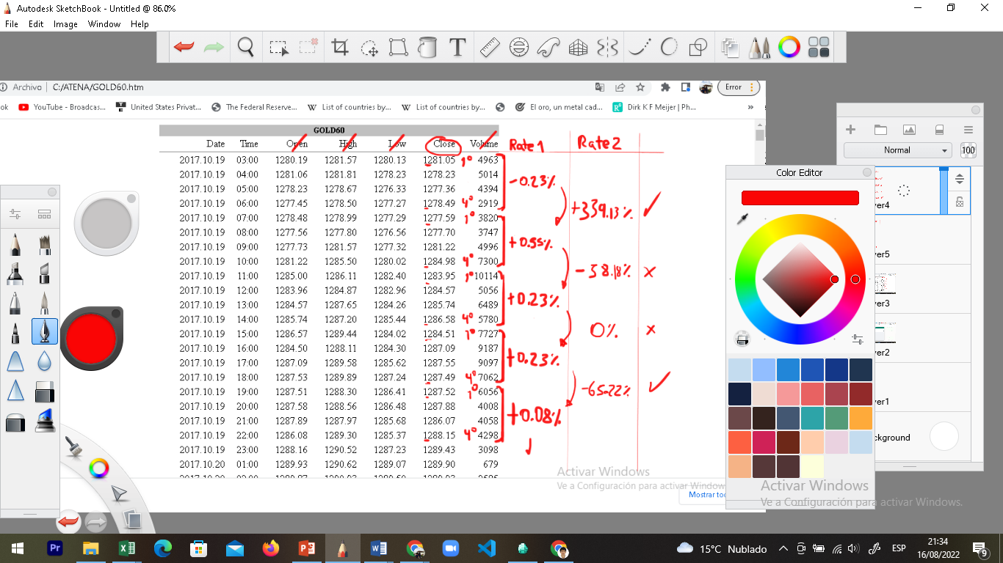

* 1. Identify the bar and place a marker under the following logical conditions:
     1. If the numerical percentage obtained is equal to or greater than 120% of the previous one, put the mark on the bar with the highest price, example: Sequence1 = (+3%); Sequence2 = (+7%), since 7 is +142% of 3, a marker would be placed on the bar with the maximum value of the group.

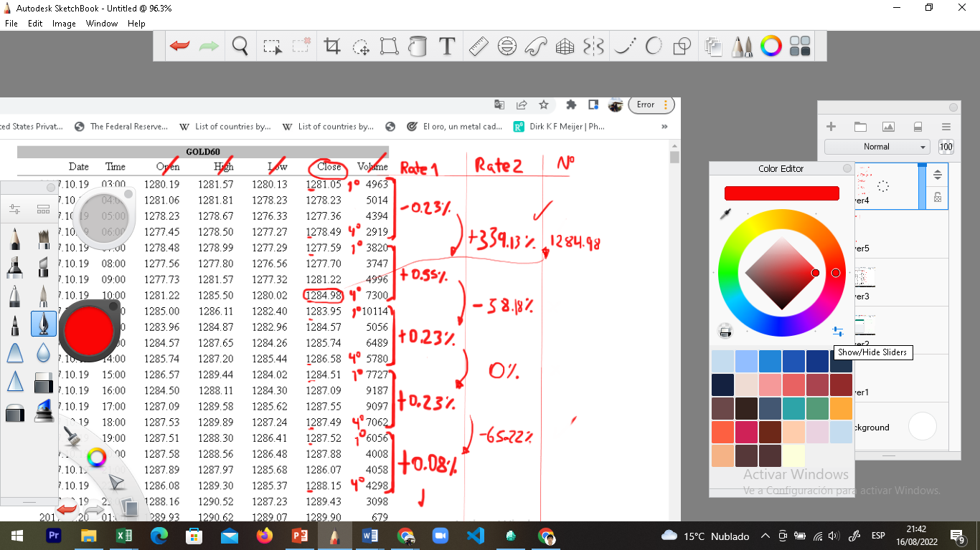

* + 1. If the numerical percentage obtained is equal to or less than -56% of the previous put, the mark to the bar with the highest price, example: Sequence1 = (+4%); Sequence2 = (+1.5%), since 1.5 is -62% of 4, a marker would be placed on the bar with the minimum value of the group.

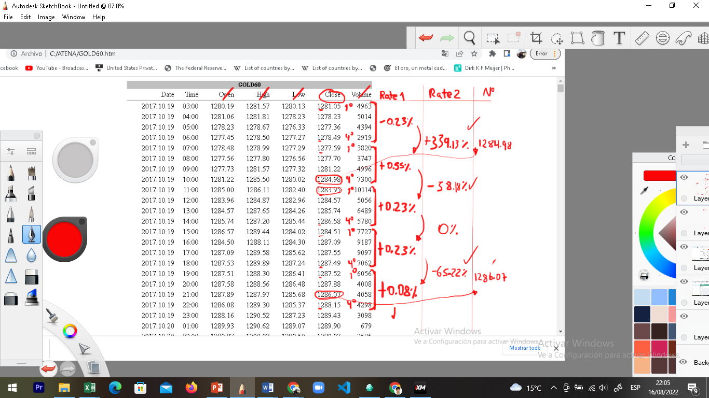

1. Once all the markers in the entire asset have been obtained, the following algorithmic formula will be next, the entire chosen database will have “markers”, both on the X (time) and Y (price) axis.
   1. On the X axis, the number of bars between each marker and another will be counted. A number will be obtained for each marker.

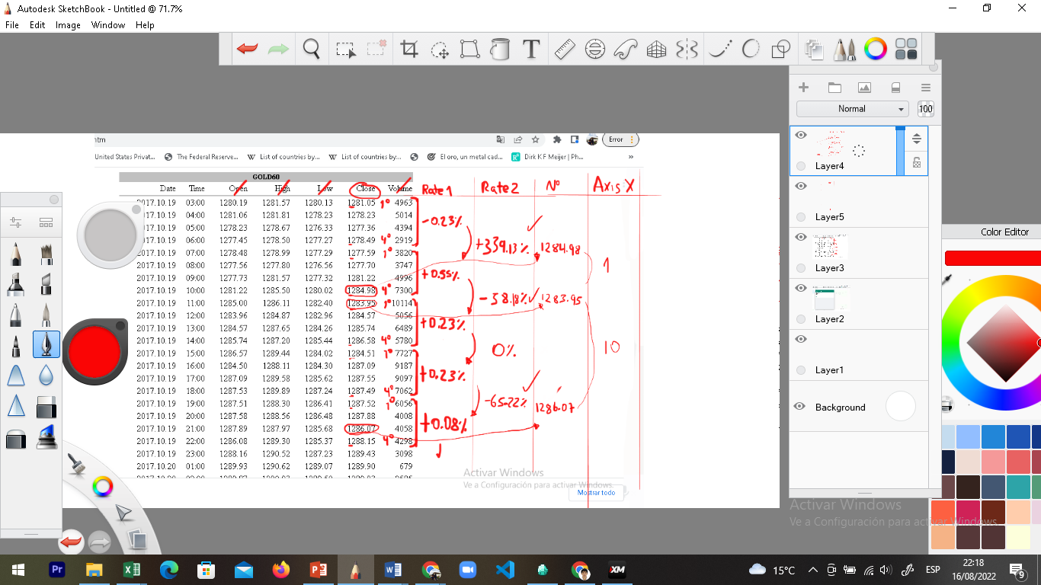

* 1. On the Y axis, the price of the last marker will be subtracted from the previous one, successively throughout the database (all results results must be in positive).

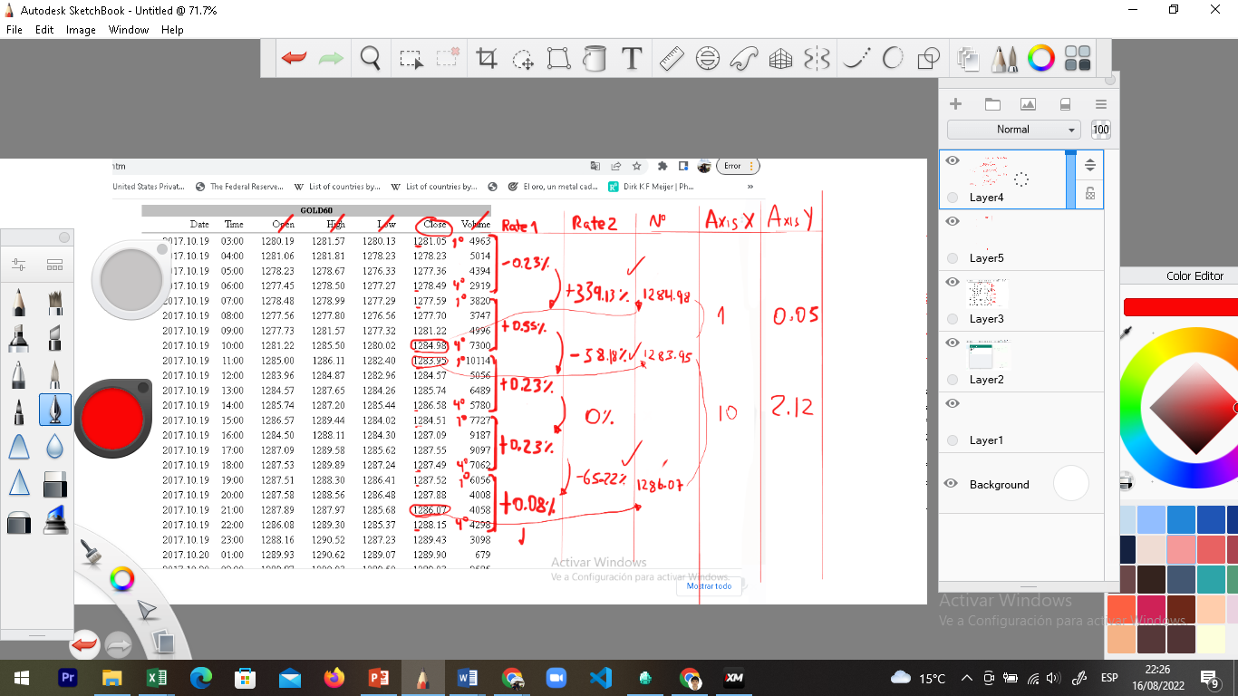

1. Finally, there will be a large number of numbers on both the X and Y axis, at that point the "piece" of the graph or series of bars of an asset will be identified and the series of numbers will be found, based on correlations.

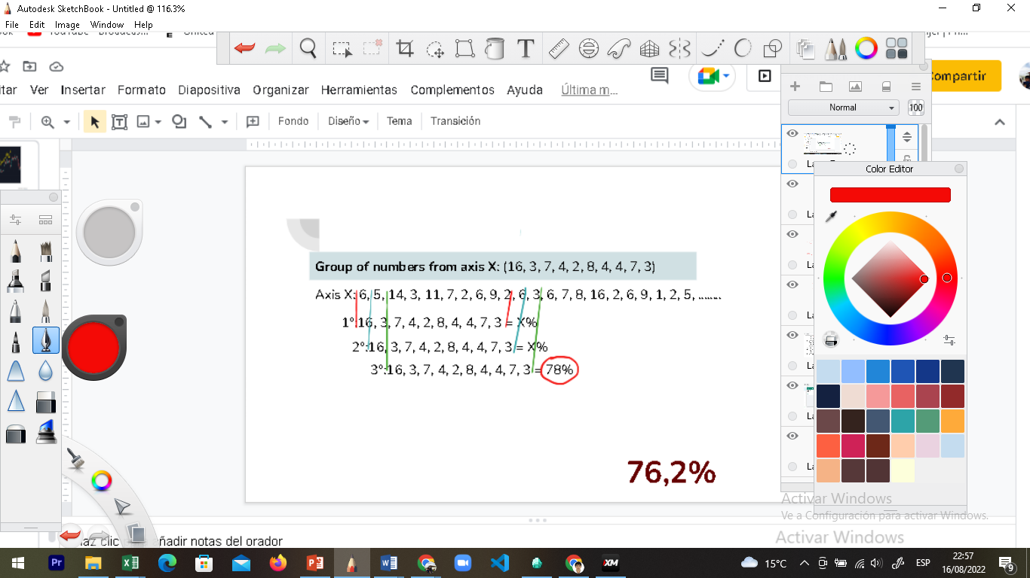

* 1. A series of numbers from Axis X or Y will be selected and a correlation will be made with each group of numbers in the entire database (of numbers based on the "markers"), the same will be done with the X and Y axis.
     1. A large number of percent correlation will be obtained, both on the X and Y axis.
     2. The 10 highest percentages of this group will be requested
        1. Each percentage must have a label of the asset and time to which it corresponds